Kids Christmas Workshops

Saturday 10 December 10-12_____________________________________________
STC1: Christmas Cups with Sarita Taylor
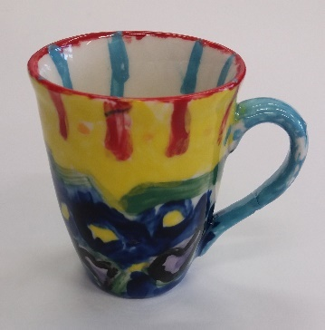
Time: 10am-12pm
Price: $20 EAC Member: $15
Min: 6 Max: 12
Duration: 2 hours
Age Group: 5-12
Come and design, then paint your own Christmas cup. A great idea for a personalised Christmas gift for someone special. Your cup will be painted on the day, then glazed and fired at the centre, ready for collection on Friday 16 December at our Christmas market (4pm-8pm).

Thursday 22 December_____________________________________________________

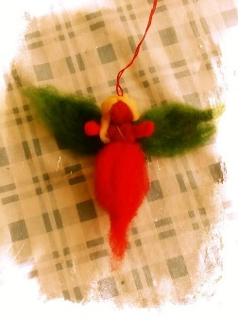
SLC1: Christmas Kids with Sue Law
Time: 10am-3pm
Price: $70 EAC Member $60
Min: 6 Max: 10
Duration: 5 Hours
Age Group: 8+
Come and make your own fleece angels and beautiful glitter Christmas cards in the style of NZ artist Reuben Patterson. A great idea for handmade, personalised Christmas gifts.

